**Networking**

**Class 10**

**Lab 22**

|  |
| --- |
| Lab Objectives:  * Network Topology |

## A Network Topology is the arrangement with which computer systems or network devices are connected to each other. Topologies may define both physical and logical aspect of the network.

## IMG_256

# Point-to-Point

## Point-to-point networks contains exactly two hosts such as computer, switches or routers, servers connected back to back using a single piece of cable.

## IMG_256

## If the hosts are connected point-to-point logically, then may have multiple intermediate devices. But the end hosts are unaware of underlying network and see each other as if they are connected directly.

# Bus Topology

## In case of Bus topology, all devices share single communication line or cable.It is one of the simple forms of networking where a failure of a device does not affect the other devices. But failure of the shared communication line can make all other devices stop functioning.

## IMG_256

## Both ends of the shared channel have line terminator. The data is sent in only one direction and as soon as it reaches the extreme end, the terminator removes the data from the line.

# Star Topology

## All hosts in Star topology are connected to a central device, known as hub device, using a point-to-point connection. That is, there exists a point to point connection between hosts and hub. The hub device can be any of the following:

## Layer-1 device such as hub or repeater

## Layer-2 device such as switch or bridge

## Layer-3 device such as router or gateway

## IMG_256

## As in Bus topology, hub acts as single point of failure. If hub fails, connectivity of all hosts to all other hosts fails. Every communication between hosts, takes place through only the hub.Star topology is not expensive as to connect one more host, only one cable is required and configuration is simple.

# Ring Topology

## In ring topology, each host machine connects to exactly two other machines, creating a circular network structure. When one host tries to communicate or send message to a host which is not adjacent to it, the data travels through all intermediate hosts.

## To connect one more host in the existing structure, the administrator may need only one more extra cable.

## IMG_256

## Failure of any host results in failure of the whole ring.Thus, every connection in the ring is a point of failure. There are methods which employ one more backup ring.

# Mesh Topology

## In this type of topology, a host is connected to one or multiple hosts.This topology has hosts in point-to-point connection with every other host or may also have hosts which are in point-to-point connection to few hosts only.

## IMG_256

## Hosts in Mesh topology also work as relay for other hosts which do not have direct point-to-point links. Mesh technology comes into two types:

## Full Mesh: All hosts have a point-to-point connection to every other host in the network.It provides the most reliable network structure among all network topologies.

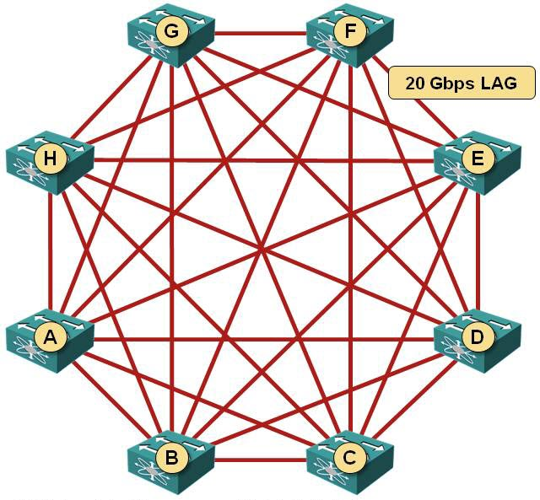

## Partially Mesh: Not all hosts have point-to-point connection to every other host. Hosts connect to each other in some arbitrarily fashion. This topology exists where we need to provide reliability to some hosts out of all.

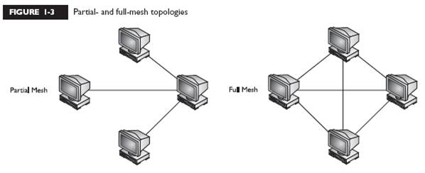

# Tree Topology

## Also known as Hierarchical Topology, this is the most common form of network topology in use presently.This topology imitates as extended Star topology and inherits properties of bus topology.

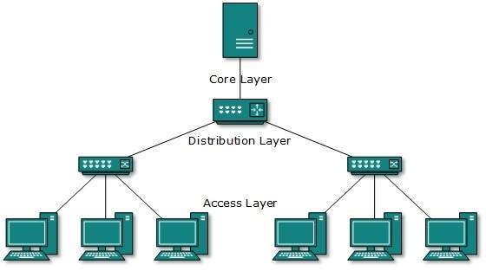

## All neighboring hosts have point-to-point connection between them.Similar to the Bus topology, if the root goes down, then the entire network suffers even.

# Daisy Chain

## This topology connects all the hosts in a linear fashion. Similar to Ring topology, all hosts are connected to two hosts only, except the end hosts.Means, if the end hosts in daisy chain are connected then it represents Ring topology.

## IMG_257

## Each link in daisy chain topology represents single point of failure. Every link failure splits the network into two segments.Every intermediate host works as relay for its immediate hosts.

# Hybrid Topology

## A network structure whose design contains more than one topology is said to be hybrid topology. Hybrid topology inherits merits and demerits of all the incorporating topologies.

## IMG_258

## The above picture represents an arbitrarily hybrid topology. The combining topologies may contain attributes of Star, Ring, Bus, and Daisy-chain topologies.

## Most WANs are connected by means of Dual-Ring topology and networks connected to them are mostly Star topology networks. Internet is the best example of largest Hybrid topology